Global Economic and Demographic Trends Analysis

1. Introduction
The purpose of this project is to analyze global economic, demographic, and health-related indicators using multiple datasets integrated into Power BI.
The analysis focuses on population trends, GDP growth, literacy, infant mortality, and regional characteristics to derive meaningful insights for decision-making and comparative country analysis.
This report documents the data sources, data preparation steps, statistical analysis, DAX calculations, visualizations, insights, and conclusions developed as part of the Power BI dashboard solution.

2. Project Objectives
The major objectives of this project are:
- Integrate SQL and Excel datasets into a unified Power BI data model.
- Perform data cleaning and transformation using Power Query.
- Conduct descriptive statistical analysis for population, GDP, literacy, and infant mortality.
- Implement DAX calculations to analyze growth rates and relationships.
- Develop interactive dashboards to visualize global economic and demographic trends.
- Derive data-driven insights across countries and regions.

3. Data Sources
The project uses four datasets from SQL and Excel.

3.1 SQL Dataset – CountriesWorld
This dataset contains country-level indicators such as:
- Country, Country Code, Region
- Population, Area, Population Density
- Coastline ratio, Net migration
- Phones per 1000 people
- Land usage (Arable, Other)
- Climate, Birthrate, Deathrate
- Economic sectors (Agriculture, Industry, Service % of GDP)

3.2 Excel Dataset – PopulationPerCountry
Contains:
- Country Name, Country Code
- Indicator Name and Code
- Population values from 1960–2017

3.3 Excel Dataset – MetaData
Includes:
- Country Code, Country Name
- Region and Income Group
- Special Notes

3.4 Excel Dataset – GDP by Country (1960–2016)
Contains:
- Country Name and Code
- Indicator Name and Code
- GDP values from 1960–2016

4. Data Cleaning and Transformation
Data preparation was completed using Power Query Editor.

4.1 Cleaning Steps
- Removed null and duplicate records.
- Corrected inconsistent country names and codes.
- Converted numeric columns to appropriate data types.
- Handled missing values using:
  - Mean/median replacement for numeric fields.
  - Removal or categorization for categorical fields.

4.2 Data Transformation
- Unpivoted year-wise population and GDP columns for time-series analysis.
- Standardized column names across datasets.
- Created relationships using Country Code and Country Name.

4.3 Data Model
- CountriesWorld linked with MetaData, Population, and GDP tables.
- Star-schema-like structure ensured efficient filtering and aggregation.

5. Descriptive Statistical Analysis
Basic statistics were calculated for major indicators.

5.1 Population
- Mean, median, mode, and standard deviation calculated across countries.
- Identified countries with highest and lowest populations.
1) Median Population = MEDIAN('GDP by Country_1960-1980'[1970])
2) Mean Population = AVERAGE('GDP by Country_1960-1980'[1960])
3) Population = STDEV.P('GDP by Country_1961-1999'[1987])
4) Total Population =
SUM('GDP by Country_1960-1980'[1960])
Population by Region =
CALCULATE(
[Total Population],
ALLEXCEPT('GDP by Country_2000-20162015', 'GDP by Country_1960-1980'[Merged])
)
5) Population Growth % =
VAR CurrentPop = SUM('GDP by Country_1960-1980'[1960])
VAR PrevPop =
CALCULATE(
SUM('GDP by Country_1960-1980'[1960]),
DATEADD('GDP by Country_1960-1980'[1960], -1, YEAR)
)
RETURN
DIVIDE(CurrentPop - PrevPop, PrevPop)
6)Top GDP Country =
TOPN(
1,
VALUES('GDP by Country_1960-1980'[Merged]),
[Avg GDP],
DESC
)

5.2 GDP Analysis
- Average GDP per capita by country and region.
- Comparison of high-income vs low-income regions.
1)Avg GDP = AVERAGE('GDP by Country_1960-1980'[1960])
2)Top GDP Country =
TOPN(
1,
VALUES('GDP by Country_1960-1980'[Merged])
[Avg GDP],
DESC)

5.3 Infant Mortality
- Range (minimum and maximum) identified.
- Standard deviation used to measure variation across regions.

5.4 Literacy Rate
- Regional average literacy calculated.
- Compared literacy with GDP levels.
- Avg Literacy = AVERAGE('GDP by Country_1960-1980'[1970])

5.5 Growth Trends (1960–2017)
- Population growth trends over time.
- GDP growth comparison between developing and developed regions.
- Decline patterns in infant mortality.

6. DAX Calculations
Key DAX measures were created in Power BI.

6.1 Population Growth Rate
Population Growth % =
DIVIDE(
SUM(Population[Value]) - CALCULATE(SUM(Population[Value]), PREVIOUSYEAR(Population[Year])),
CALCULATE(SUM(Population[Value]), PREVIOUSYEAR(Population[Year]))
)

6.2 GDP Growth Rate
GDP Growth Overall % =
VAR GDP1960 =
CALCULATE(
[Avg GDP],
'GDP by Country_1960-1980'[1961] = 1960
)

VAR GDP2017 =
CALCULATE(
[Avg GDP],
'GDP by Country_2000-20162015'[2006] = 2017
)

RETURN
DIVIDE(GDP2017 - GDP1960, GDP1960)

6.3 GDP per Capita (Calculated Column)
GDP per Capita = DIVIDE(GDP[Value], Population[Value])

6.4 Regional Aggregations
- Total population by region.
- Average GDP per capita by region.

6.5 Correlation Insight
- Compared Literacy Rate vs GDP per Capita to identify positive relationships.
IMR_Category =
IF(
'GDP by Country_1960-1980'[Avg GDP] > [Max Avg GDP],
"Above Average",
"Below Average"
)

7. Data Visualizations in Power BI
The dashboard includes multiple interactive visuals:
- Line Chart – Population growth over time.
- Bar Chart – GDP per capita by country.
- Map Visualization – Population density by region.
- Scatter Plot – Literacy vs GDP relationship.
- Area Chart – Infant mortality trend over time.
- Slicers and Filters – Region, country, and year selection.
The dashboard layout ensures clarity, interactivity, and storytelling.

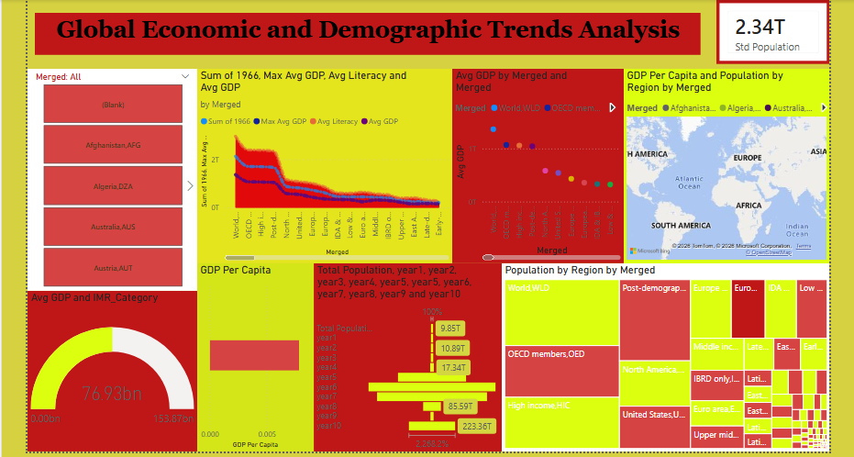

8. Key Insights
Major findings from the analysis include:
- Regions in Asia and Africa show the highest population growth rates.
- Higher literacy rates strongly correlate with higher GDP per capita.
- Developed countries exhibit low infant mortality and stable GDP growth.
- Population density is highest in South Asia and parts of Europe.
- Infant mortality has declined globally since 1960, especially in middle-income countries.

9. Conclusion
This project successfully integrates multiple global datasets into Power BI to provide a comprehensive view of economic and demographic trends.
The analysis highlights:
- Strong linkage between education, health, and economic development.
- Significant regional disparities in growth and living standards.
- Long-term improvements in global health indicators.
The developed dashboard enables policymakers, researchers, and analysts to explore trends interactively and make informed decisions.

